Program Information | [Lesson Title}  Taking Notes for Class |  |  |  |  |  | TEACHER NAME  Judy Franks |  |  |  | PROGRAM NAME  Ohio Literacy Resource Center
Program Information | [Unit Title]  College Success Skills |  |  |  |  |  | NRS EFL(s)  3 – 4 |  |  |  | TIME FRAME  60 – 120 minutes
Instruction | OBR ABE/ASE Standards – English Language Arts and Literacy
Instruction | Reading (R) |  |  |  | Writing (W) |  |  | Speaking & Listening (S) |  |  |  | Language (L)
Instruction | Foundational Skills |  |  |  | Text Types and Purposes |  |  | Comprehension and Collaboration |  |  |  | Conventions of Standard English
Instruction | Key Ideas and Details |  | R.3.5  R.4.2 |  | Production and Distribution of Writing | W.4.3 |  | Presentation of Knowledge and Ideas |  |  |  | Knowledge of Language
Instruction | Craft and Structure |  | R.3.10  R.4.6 |  | Research to Build and Present Knowledge |  |  |  |  |  |  | Vocabulary Acquisition and Use
Instruction | Integration of Knowledge and Ideas | R.3.17
Instruction | LEARNER OUTCOME(S)  - Students will locate the key ideas in a short biography and practice the note-taking strategies of SQ3R, Cornell and outlining. |  |  |  |  |  |  |  | ASSESSMENT TOOLS/METHODS  - Key ideas from 1 x 2 papers  - Notes from SQ3R, Cornell and outline activities  - Actual notes from class  - Summary list
Instruction | LEARNER PRIOR KNOWLEDGE  - If students have not attended high school, they will have had little experience taking notes during class. Finding key ideas and summarizing will have been introduced, with students still needing more practice with these skills to become proficient.
Instruction | INSTRUCTIONAL ACTIVITIES  - In preparation for attending a college class, students will be given the opportunity to practice note taking strategies. Students often struggle to identify the key ideas when reading text or listening to a lecture.  Display a sample of the largest sticky note and explain to students that this activity is going to include three brief writing assignments - each successive assignment will require them to write less. Read aloud a brief biography or have students read to themselves the handout Isaac Newton Biography. During the first reading, students should not take notes, only listen carefully and consider all the details that are most significant. Read the passage again and students should jot down notes on a 3 x 5 card. They should fill the card with their notes (remind them to pay close attention to the size of their writing). Students should study the notes on their large card and eliminate some of the less important information. They should transfer the remaining information to the medium-sized (2 x 3) card. Narrow down those notes to the most important information that will fit on a small 1 x 2 sticky note or card.  Emphasize to students that this lesson in note taking is intended to help them see that note taking is about scaling down information to the most important details. When reviewing their notes, they should "boil down" the notes to key facts, ideas or themes. These key concepts could be written in margin notes and also used when studying for tests.  Teacher Note This lesson has been planned based on students preparing to attend a physics class, Seven Ideas That Shook the Universe, at a local university. Any content (science, history, literature, etc.) can be used to teach note taking, based on the goals of your students.  - Start your discussion with students by asking them why they need to take notes as future university students. Using the Note Taking PowerPoint slides 1-5, talk through the note taking process with students asking which of these processes they have used and how it has worked with them. Also, discuss which tips they think would be especially helpful to promote being a successful student.  - Introduce the SQ3R study method in Note Taking PowerPoint slide 6 by using a Think Aloud teaching strategy with the Centripetal & Centrifugal Force handout. Use the think aloud on the first page:  Survey - notice that the title has 2 related words, both starting with 'centri' which looks like center; there's a website - maybe this information came from there; there are bolded words - I wonder about their importance; and there's a graphic that might help me understand.  Question - What's the difference between centripetal and centrifugal force? How are these concepts related to circular motion? Which force acts toward the center of the motion? How would knowing the Latin roots help me understand the concepts?  Read- take a couple minutes to read the article and find the answers to my questions; my notes might include this information: they both deal with circular motion- one of objects rotating inward, the other with objects rotating outward, but there is only centripetal (inward) force and inertial that makes objects move outward, centripetal force acts toward the center of the motion (bold words) and Latin roots of centripetal mean "seeking the center" while centrifugal means "fleeing the center"; the graphic shows how centripetal force always acts toward the center. I could also use a highlighter to mark words and phrases as my notes.  Recite - centripetal means toward the center, centrifugal means away from the center and is really a reaction or inertia from the motion to the center.  Review - I will look over my notes tomorrow to help me remember the difference between the two forces.  Students practice using SQ3R on text starting at Real-Life Applications (pgs. 2-3). Pair up with another student and share your responses. Debrief as a group about how the strategy worked for them.  - For visual learners, the Cornell method might be a helpful tool to use especially during lectures. Cornell Notes was invented in the 1950s by Walter Pauk, an education professor at Cornell University.  Using Note Taking PowerPoint slides 7-8, talk through the process and share the Cornell Notes template with students. To simulate a lecture, the teacher might want to read through the chapter on Circular Motion (maybe only part of text as time/interest allows). Students can practice taking notes (step 1) on the right side of the sheet. Do step 2 together as a class - have students pull out the key words and ideas and put these in the left-hand column. Then each student can write a summary of the material at the bottom of the page.  Introduce the Cornell Notetaking. This can be used as a learning cue for students to help them remember the process. Suggest they keep it in their notebooks in preparation for the class so they can review before they take notes.  - Students may comment about the teacher talking too fast during the last activity. This will open discussion about the handout When Your Instructor Talks Fast.  Outline methods can also be used as a note taking technique - working especially well for some lectures, but also for reading textbooks. There are other approaches students might like to practice using this article; they can follow a traditional linear outline or a Semantic Mapping strategy. Teacher can demonstrate each of these formats on the board. For this article, the linear outline might look like this:  A. Before class  1.  B. During class  1.  C. After class  1.  The semantic map might look like this:  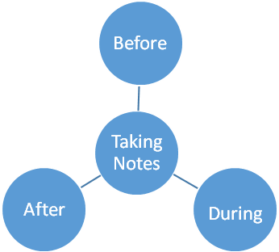  - Review and summarize the general tips for note taking discussed today. Post these on chart paper in the classroom. Students and teacher attend the university class and practice their note taking skills, debrief after and determine successes and if additional practice is needed. |  |  |  |  |  |  |  | RESOURCES  Three sticky notes or index cards in three different sizes - 3 x 5, 2 x 3, and 1 x 2 for each student  Student copies of Isaac Newton Biography handout (attached)  Note Taking PowerPoint slides (attached)  Think Alouds [PDF file]. (n.d.). Retrieved from http://literacy.kent.edu/eureka/strategies/think_aloud09.pdf  Highlighters for student use  Student copies of Centripetal & Centrifugal Force handout (attached)  Student copies of Cornell Notes template (attached)  Student copies of Cornell Notetaking (attached)  Student copies of When Your Instructor Talks Fast (attached)  Semantic Mapping [PDF file]. (n.d.). Retrieved from http://literacy.kent.edu/eureka/strategies/semantic_mapping09.pdf  Additional resources:  Introduction To The Cornell Method of Note Taking. (n.d.). Retrieved from http://wn.com/introduction_to_the_cornell_method_of_note_taking  Note Taking [PDF file]. (n.d.). Retrieved from http://coe.jmu.edu/learningtoolbox/printer/iswam.pdf  Ellis, D. B., Toft, D., Mancina, D., & McMurray, E. L. (2006). Becoming a master student. Boston: Houghton Mifflin.  Barrick, J. & Emmons, T. (2010). Seven Ideas That Shook the Universe. Circular Motion. Kent State University, 15-1.  Lesson 2.1 Textbooks and Other Educational materials. Common core basics: Building essential test readiness skills (Reading). (2015). Columbus, OH: McGraw-Hill Education.
DIFFERENTIATION
- The Cornell chart is helpful for visual learners, as well as students being able to use the semantic map as a graphic organizer to scaffold their learning.
- The Cornell Notetaking is used as a learning cue for what students have learned and practiced during this lesson. This could be made into a bookmark for students to use as an aid when reading new content.

Reflection | TEACHER REFLECTION/LESSON EVALUATION
Reflection | ADDITIONAL INFORMATION  Reinforce these note taking strategies with future assignments.

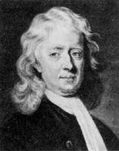
Isaac Newton (1642-1727), English mathematician and physicist, generally regarded as the most original and influential theorist in the history of science. In addition to his invention of the infinitesimal calculus and a new theory of light and color, Newton transformed the structure of physical science with his three laws of motion and the law of universal gravitation. As the keystone of the scientific revolution of the 17th century, Newton's work combined the contributions of Copernicus, Kepler, Galileo, Descartes, and others into a new and powerful synthesis.

Life & Character In 1642, the year Galileo died, Isaac Newton was born prematurely in Woolsthorpe, Lincolnshire, England on Christmas Day. The posthumous son of an illiterate yeoman (also named Isaac); the fatherless infant was small enough at birth to fit 'into a quart pot.' When Isaac was three, his mother married a wealthy elderly clergyman from the next village, and went to live there, leaving Isaac behind with his grandmother. The clergyman died, and Isaac’s mother came back, after eight years, bringing with her three small children. Newton's childhood was anything but happy, and throughout his life he verged on emotional collapse, occasionally falling into violent and vindictive attacks against friend and foe alike. Two years later, Newton went away to the Grammar School in Grantham, where he lodged with the local apothecary, and was fascinated by the chemicals. The plan was that at age seventeen he would come home and look after the farm. He turned out to be a total failure as a farmer.

Isaac entered Cambridge University in 1661and paid his way through college for the first three years by waiting tables and cleaning rooms for the fellows (faculty) and the wealthier students. In 1664, he was elected a scholar. Due to the plague and school closing, Newton returned home, where he spent two years concentrating on problems in mathematics and physics. Being at the height of his creative power - the prime of his age for invention - Newton wrote that during this time he first understood the theory of gravitation and optics (white light is made up of the colors of the rainbow), and much mathematics.

The three laws of motion were first compiled in his work Philosophiae Naturalis Principia Mathematica (Mathematical Principles of Natural Philosophy) commonly known as the Principia, although this was not published until 1687.
Newton's Laws of Motion Three physical laws that form the basis for classical mechanics. They describe the relationship between the forces acting on a body and its motion due to those forces. They have been expressed in several different ways over nearly three centuries, and can be summarized as follows:
- First law of motion: An object at rest will remain at rest, and an object in motion will remain in motion, at a constant velocity unless or until outside forces act upon it.
- Second law of motion: The net force acting upon an object is a product of its mass multiplied by its acceleration.
- Third law of motion: When one object exerts a force on another, the second object exerts on the first a force equal in magnitude but opposite in direction.

Sir Isaac Newton Biography Handout
Sir Isaac Newton Biography Handout

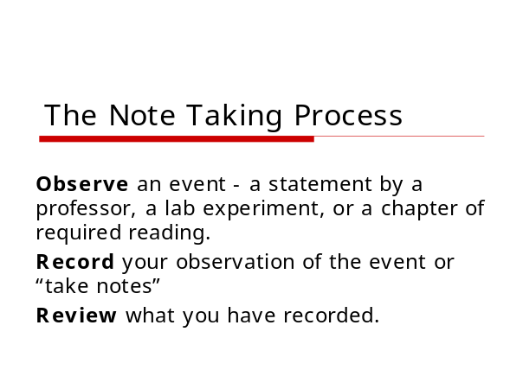 | ___________________________________  ___________________________________  ___________________________________  ___________________________________  ___________________________________  ___________________________________  ___________________________________
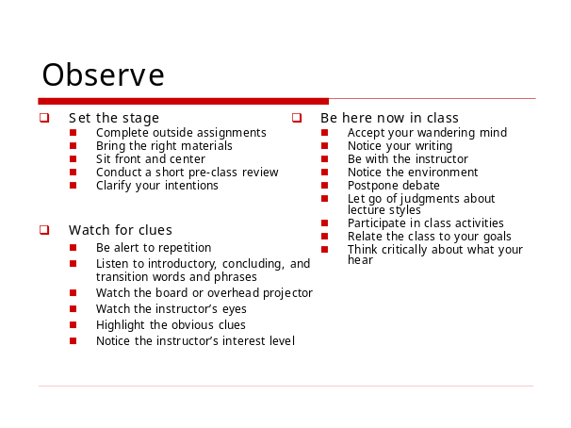 | ___________________________________  ___________________________________  ___________________________________  ___________________________________  ___________________________________  ___________________________________  ___________________________________
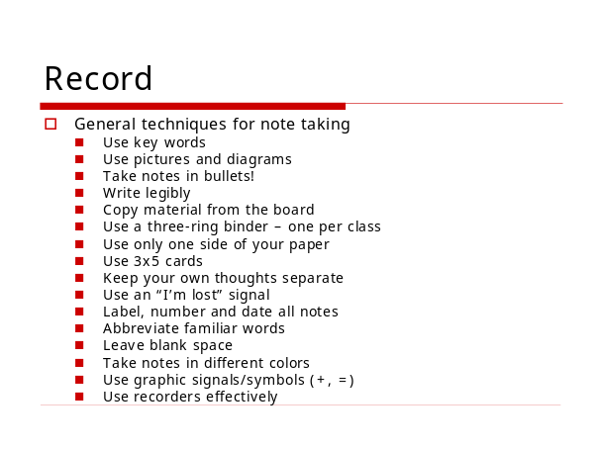  Note Taking PPT | ___________________________________  ___________________________________  ___________________________________  ___________________________________  ___________________________________  ___________________________________  ___________________________________
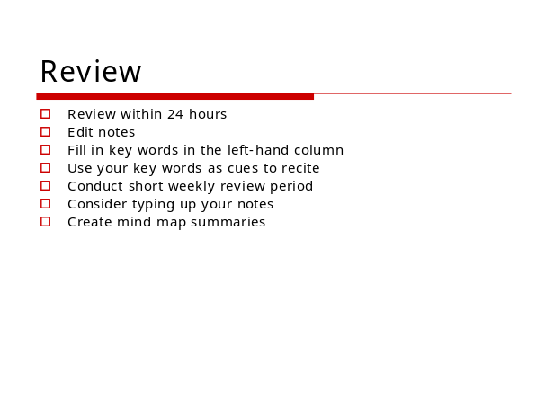 | ___________________________________  ___________________________________  ___________________________________  ___________________________________  ___________________________________  ___________________________________  ___________________________________
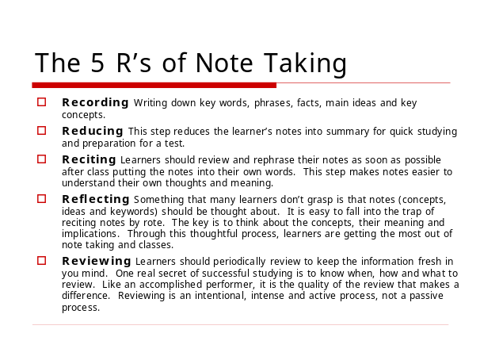 | ___________________________________  ___________________________________  ___________________________________  ___________________________________  ___________________________________  ___________________________________  ___________________________________
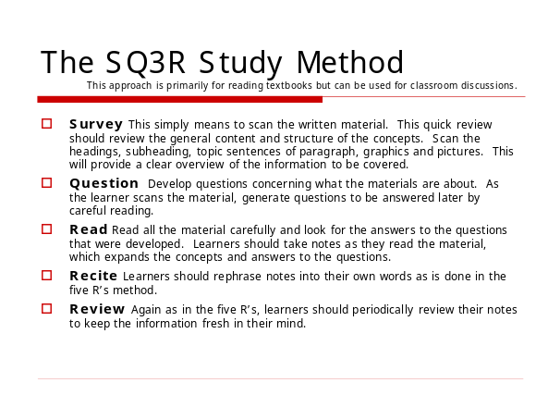  Note Taking PPT | ___________________________________  Note Taking PPT  ___________________________________  ___________________________________  ___________________________________  ___________________________________  ___________________________________  ___________________________________
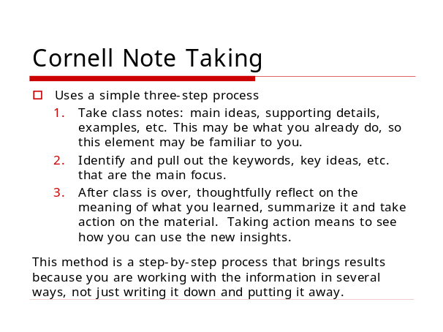 | ___________________________________  ___________________________________  ___________________________________  ___________________________________  ___________________________________  ___________________________________  ___________________________________
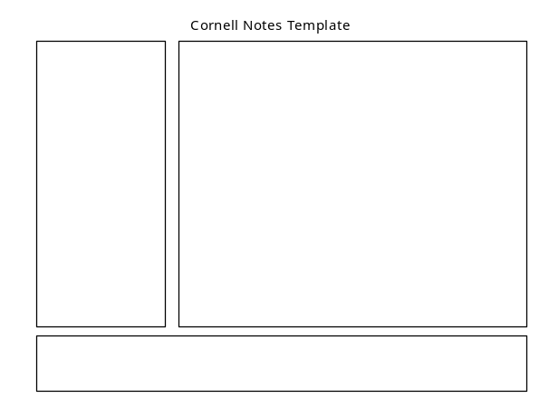 | ___________________________________  ___________________________________  ___________________________________  ___________________________________  ___________________________________  ___________________________________  ___________________________________

Centripetal Force and Centrifugal Force

Concept

Most people have heard of centripetal and centrifugal force. Though it may be somewhat difficult to keep track of which is which, chances are anyone who has heard of the two concepts remembers that one is the tendency of objects in rotation to move inward, and the other is the tendency of rotating objects to move outward. It may come as a surprise, then, to learn that there is no such thing, strictly speaking, as centrifugal (outward) force. There is only centripetal (inward) force and the inertia that makes objects in rotation under certain situations move outward, for example, a car making a turn, the movement of a roller coaster—even the spinning of a centrifuge.
Centripetal Force
When there is no external force, an object will travel in a straight line (Newton's First Law of Motion). In order for an object to travel in a circle, there has to be a force that makes it travel in a circle.
An object in circular motion always tries to move in a straight line (Law of Inertia). However, there is a force that acts toward the center of the motion. This force is called the centripetal force. It is the centripetal force that makes an object travel in a circular path. This force could be friction or a gravitational force, but we call it a centripetal force.
The Latin roots of centripetal together mean "seeking the center." What, then, of centrifugal, a word that means "fleeing the center"? It would be correct to say that there is such a thing as centrifugal motion; but centrifugal force is quite a different matter. The difference between centripetal force and a mere centrifugal tendency—a result of inertia rather than of force—can be explained by referring to a familiar example.
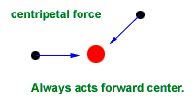
Real-Life Applications

Riding in a Car

Centripetal force is commonly seen when driving a car. If the car approaches a curve, the road must be engineered to compensate for the curve. The road must provide an additional force so that the car can round the curve and not continue on a straight path.
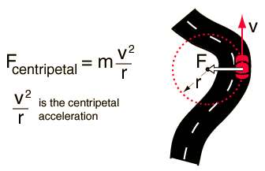 | Centripetal Force  Now we will consider the effects of centripetal force, as well as the illusion of centrifugal force. When a car turns to the left, it is undergoing a form of rotation, describing a 90°-angle or one-quarter of a circle. Once again, your body experiences inertia, since it was in motion along with the car at the beginning of the turn, and thus you tend to move forward. The car, at the same time, has largely overcome its own inertia and moved into the leftward turn. Thus the car door itself is moving to the left. As the door meets the right side of your body, you have the sensation of being pushed outward against the door, but in fact what has happened is that the door has moved inward.
The centripetal acceleration can be derived for the case of circular motion since the curved path at any point can be extended to a circle. The acceleration of a body experiencing uniform circular motion is always directed toward the center of the circle, so we call that acceleration centripetal acceleration,. Centripetal comes from a Latin word meaning “center-seeking.” We define the centripetal acceleration of a body moving in a circle as:
where v is the body’s velocity, and r is the radius of the circle. The body’s centripetal acceleration is constant in magnitude but changes in direction. Note that even though the direction of the centripetal acceleration vector is changing, the vector always points toward the center of the circle.

Centrifugal force is the force which describes the outward pressure that is exhibited around an object rotating around a central point. The centrifugal force definition is based on a Latin phrase which means "fleeing the center," an accurate description based on what is being observed. There are some physicists who claim that true centrifugal forces do not exist, that an object's reaction to such a force can be explained by other means.
One possible explanation for centrifugal force rests in Newton's law of inertia. This law states that an object in a uniform motion tends to stay in that same motion unless there is pressure exerted by an outside force. For example, a ball being twirled around on a string would tend to go in a straight line if not for the string and the force the string puts on the ball. Therefore, the ball, instead of going in a straight line, goes in a circular motion around the center of the pivot.
Though the concept is not readily understood, the benefits of what many people refer to as centrifugal force are used for the benefit of mankind. For example, centrifugal force is what dries clothes in a dryer. Along with the heat that is used, the dryer also spins the clothes, much like a washing machine does, to get the majority of water out of them before the dryer finishes the job.
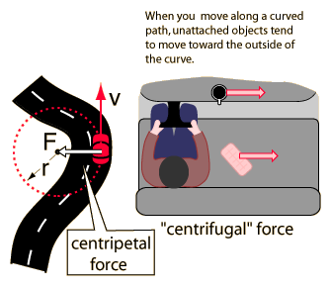 | Centrifugal Force  The driver of a car on a curve is in a rotating reference frame and he could invoke a "centrifugal" force to explain why his coffee cup and the carton of eggs he has on the seat beside him tend to slide sideways. The friction of the seat or dashboard may not be sufficient to accelerate these objects in the curved path.

Videos

Circular Motion. (n.d.). Retrieved from http://www.youtube.com/watch?v=-G7tjiMNVlc

Centripetal Force - Cool Science Experiment. (n.d.). Retrieved from http://www.youtube.com/watch?v=yyDRI6iQ9Fw&feature=related

Centri-petal Force. (n.d.). Retrieved from http://www.answers.com/topic/centripetal-force

Centripetal Force. (n.d.). Retrieved from http://hyperphysics.phy-astr.gsu.edu/hbase/cf.html

What is Physics? (n.d.). Retrieved from http://www.wisegeek.org/what-is-physics.htm

What is Inertia? (n.d.). Retrieved from http://www.wisegeek.org/what-is-inertia.htm

CIRCULAR MOTION

If a car is seen to be increasing its speed, we say it is accelerating', If the car is decreasing its speed, it is decelerating. What about a car that maintains a constant speed, but changes direction? Even though it doesn't move faster or slower, it is still accelerating. The reason for this goes back to the isotropic property of space. The three dimensions of space are independent of one another.

When an object moves around a curve, it is in effect slowing down in one dimension while gaining speed in another dimension. Thus the object is undergoing two accelerations at once -- an increase in speed in one direction while decreasing speed in another. .

Referring to diagram 15A, when the ball is at the top of the curve (position #1), it is moving horizontally toward the right. But when the ball is at the side of the curve (position #2), the ball is moving in a downward direction. It stopped moving sideways and started moving downward. It has undergone acceleration.

Position # 1


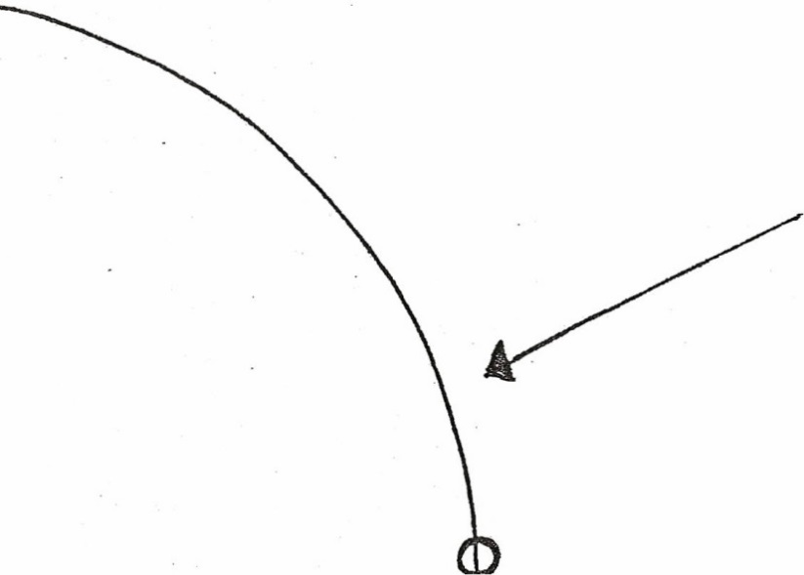
Diagram 15-A
Position # 2

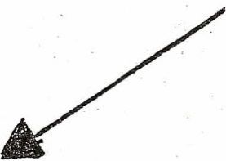

Inward force

Newton says that in order for an object to accelerate, there must be a net force acting on it. To
make an object move faster, the force pushes forward on the object. To make an object slow
down, the force must push back on the object. To make an object accelerate by changing its
direction, the force pushes sideways. It pushes the object toward the center of the arc around
which it is moving. The arrows in diagram 15-A show the direction of the force needed to make
the ball round the curve. This inward force is centripetal force. It can come from the force of
gravity, the electromagnetic force, the strong interacting force, or the weak interacting force.

Newton's third law tells us that for every force pushing in one direction, there will be an equal
- but opposite reacting force. The centripetal force pushing an object inward around a circle will
generate a reacting force which is felt by the object. This outward force is centrifugal force that
should really be called centrifugal reaction.
This outward centrifugal force is felt by people rounding a curve in an automobile. We are
forced outward away from the center of the arc as friction between the front tires and the road
pushes the car inward. You might think of centrifugal force as a force you feel when a car rounds
a bend. Inside this car, you tend to keep going straight and therefore you push against the door
while the car is turning.
On the scale of a single atom, we see the roll played between centripetal force and centrifugal
force. The positive protons in the nucleus pull inward on the negative electrons (opposite charges
attract). The electrons would fall into the nucleus if it were not for the fact that they are moving.
The inward pull on the electrons is a centripetal force causing the electrons to move in an orbit,
while the outward centrifugal reaction holds the electrons away from the nucleus.
On a large scale, the sun's gravity pulls inward on the Earth. We would fall into the sun if we
were not moving in our orbit: The sun's gravity supplies the' centripetal force and the Earth
experiences centrifugal force holding us away from the sun.
When a satellite is sent into orbit around the Earth, it does not remain in orbit because it is away
from the Earth's gravity. The Earth's gravity still pulls the satellite toward the center of the Earth,
but because the satellite was launched so as to attain a speed of 18,000 miles per hour parallel to
the 'surface of the Earth, gravity accelerates the satellite by changing its direction.' This causes the
satellite to experience' centrifugal force and holds it above the ground.
Any object moving in an orbit has a quantity called angular momentum. Angular momentum
will cause an object to move faster if the radius of the orbit is decreased. Likewise, if the radius is
increased, the object will slow down. We see this exemplified when a spinning ice skater pulls his
or her arms into the body, causing the skater to spin faster.

Barrick, J. & Emmons, T. (2010). Seven Ideas That Shook the Universe. Circular Motion. Kent State University, 15-1.

Cornell Notes
Name |  | Date
Topic |  | Class
Recall Column | Note taking Column
Summary

 Cornell Note taking

 Cornell Note taking

Preparation for note taking
- use separate page for each day - date it and write topic at top
- prepare notebook by drawing following page:

Name | Date
Topic | Class

Recall Column | Note taking Column
Summary

- review previous notes to make connections – overlap each page so only the recall column can be seen

Recording notes during presentation
- keep notes simple
- paraphrase
- record main ideas
- link supporting details- use bullets
- use key words/phrases - abbreviate/use symbols
- bold/underline vocabulary and meaning
- give examples
- listen for clues and signal words
- listen for repetition of points
- listen for compare/contrast
- watch teacher gestures, changes in voice
- write down anything on the board

Review
- ASAP after presentation, review notes, highlighting or underlining key ideas, add any missed material
- to help jog the memory - use the recall column to fill in key words/phrases/questions/vocabulary
- cover up notes and use key words to recall material aloud uncover to check for accuracy

Preparation for note taking
- use separate page for each day - date it and write topic at top
- prepare notebook by drawing following page:

Name | Date
Topic | Class

Recall Column | Note taking Column
Summary

- review previous notes to make connections - overlap each page so
only the recall column can be seen

Recording notes during presentation
- keep notes simple
- paraphrase
- record main ideas
- link supporting details- use bullets
- use key words/phrases - abbreviate/use symbols
- bold/underline vocabulary and meaning
- give examples
- listen for clues and signal words
- listen for repetition of points
- listen for compare/contrast
- watch teacher gestures, changes in voice
- write down anything on the board

Review
- ASAP after presentation, review notes, highlighting or underlining key
ideas, add any missed material
- to help jog the memory - use the recall column to fill in key
words/phrases/questions/vocabulary
- cover up notes and use key words to recall material aloud uncover
to check for accuracy
talks fast
Take more time to prepare for class.
Familiarity with a subject increases your ability
When your instructor
to pick up on key points. If an instructor lectures quickly
or is difficult to understand, conduct a thorough preview.
Be willing to make choices. When an instructor talks
fast, focus your attention on key points. Instead of trying
to write everything down, choose what you think is
important. Occasionally, you will make a wrong choice
and neglect an important point. Worse things could
happen. Stay with the lecture, write down key words, and
revise your notes immediately after class.
Exchange photocopies of notes with classmates.
Your fellow students might write down something you
missed. At the same time, your notes might help them.
Exchanging photocopies can fill in the gaps.
Learn shorthand. Some note-taking systems, known as
shorthand, are specifically designed for getting ideas
down fast. Books and courses are available to help you
learn these systems. You can also devise your own
shorthand method by inventing one- or two-letter
symbols for common words and phrases.

Ask questions-even if you're totally lost. Many
instructors allow a question session. This is the time to
ask about the points you missed. There might be times when you feel so lost that you can't even formulate a question. That's OK. One option is to report this fact to the instructor. She can often guide you to a clear question. Another option is to ask a related question. This might lead you to the question you really wanted to ask.

Ask the instructor to slow down. This is the most
obvious solution. If asking the instructor to slow down
doesn't work, ask her to repeat what you missed

Joining a study group has helped me to improve
my note taking skills. My group members rely
on me to take neat notes in class, especially to.
help the other group members to fill in places
that they've missed. Now when my Psychology
professor talks fast, I don't panic. Sharing the
notes after class helps my whole group get the
important information.
-MARCO JUAREZ

Leave large empty spaces in your notes. Leave plenty
of room for filling in information you missed. Use a
symbol that signals you've missed something, so you can
remember to come back to it.

See the instructor after class. Take your class notes
with you and show the instructor what you missed.

Use a tape recorder. Taping a lecture gives you a
chance to hear it again whenever you choose. Some
recorders allow you to vary the speed of the tape. With
this feature, you can perform magic and actually slow
down the instructor's speech.

Before class, take notes on your reading
assignment. You can take detailed notes on the text
before class. Leave plenty of blank space. Take these notes
with you to class and simply add your lecture notes to
them.

Go to the lecture again. Many classes are taught in
multiple sections. That gives you the chance to hear a
lecture at least twice-once in your regular class and
again in another section of the class.
Voices
Ellis, D. (2006). When Your Teacher Talks Fast. Becoming a Master Student. New York: Houghton Mifflin Co, 174.
.

